**Created AWS Resources using AWS CLI**

To create a **trust policy** that allows a specific IAM user, group, or service to assume a role with full access to EC2, you will need to:

1. Create a trust policy that allows the entity to assume the role.
2. Attach a permissions policy to the role that grants full access to EC2.

**Prerequisites tools required for this project: -**

* Need one Ubuntu Linux Machine or VM.
* IAM User with Access key and Secret Access key.
* AWS CLI Installation.

**Here’s how I do it**:

1. **Create an IAM Role with a Trust Policy :**

Here’s how I created an IAM role named **Test-Role** and attach a trust policy to it using the AWS CLI.

**Step-by-Step Guide:**

1. **Create the Trust Policy JSON Document**:
   * Create a file named **Test-Role-Trust-Policy.json** with the following content. This example trust policy allows the AWS Lambda service to assume the role.

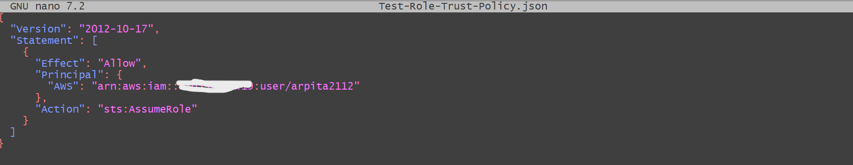

{

"Version": "2012-10-17",

"Statement": [

{

"Effect": "Allow",

"Principal": {

"Service": "**arn:aws:iam::730335449419:user/arpita**"

},

"Action": "sts:AssumeRole"

}

]

}

### **Step 2: Create the IAM Role with the Trust Policy**

1. **Run the AWS CLI Command to Create the Role**:
   * Use the **aws iam create-role** command to create the role and attach the trust policy document to it.

aws iam create-role \

--role-name **Test-Role** \

--assume-role-policy-document <file://Test-Role-Trust-Policy.json>

### **Step 3: Attach the Full Access Permissions Policy to the Role**

1. **Create the Permissions Policy JSON Document**:
   * Create a file named **EC2FullAccessPolicy.json** with the following content. This policy grants full access to EC2.

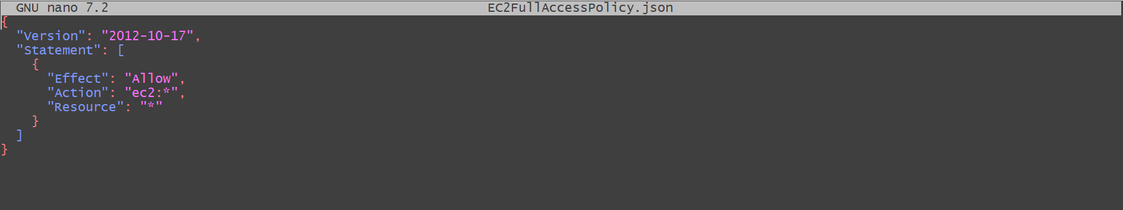

{

"Version": "2012-10-17",

"Statement": [

{

"Effect": "Allow",

"Action": "**ec2:*",**

"Resource": "*"

}

]

}

**Create the Policy and Attach it to the Role**:

* First, create the policy:

**aws iam create-policy \**

**--policy-name EC2FullAccessPolicy \**

**--policy-document** **file://EC2FullAccessPolicy.json**

• Note the **PolicyArn** returned by the previous command, as you will need it to attach the policy to the role.

• Then, attach the policy to the role:

**aws iam attach-role-policy \**

**--role-name Test-Role \**

**--policy-arn arn:aws:iam::123456789012:policy/EC2FullAccessPolicy // Replace with the actual PolicyArn**

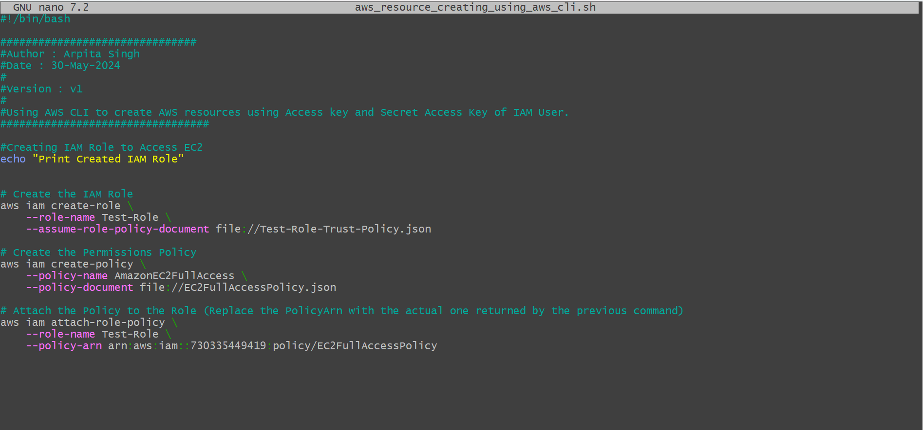

By following these steps, you can create an IAM role that allows a specific principal to assume the role and grants full access to EC2. Make sure to replace placeholders like account IDs and ARNs with actual values from your AWS environment.

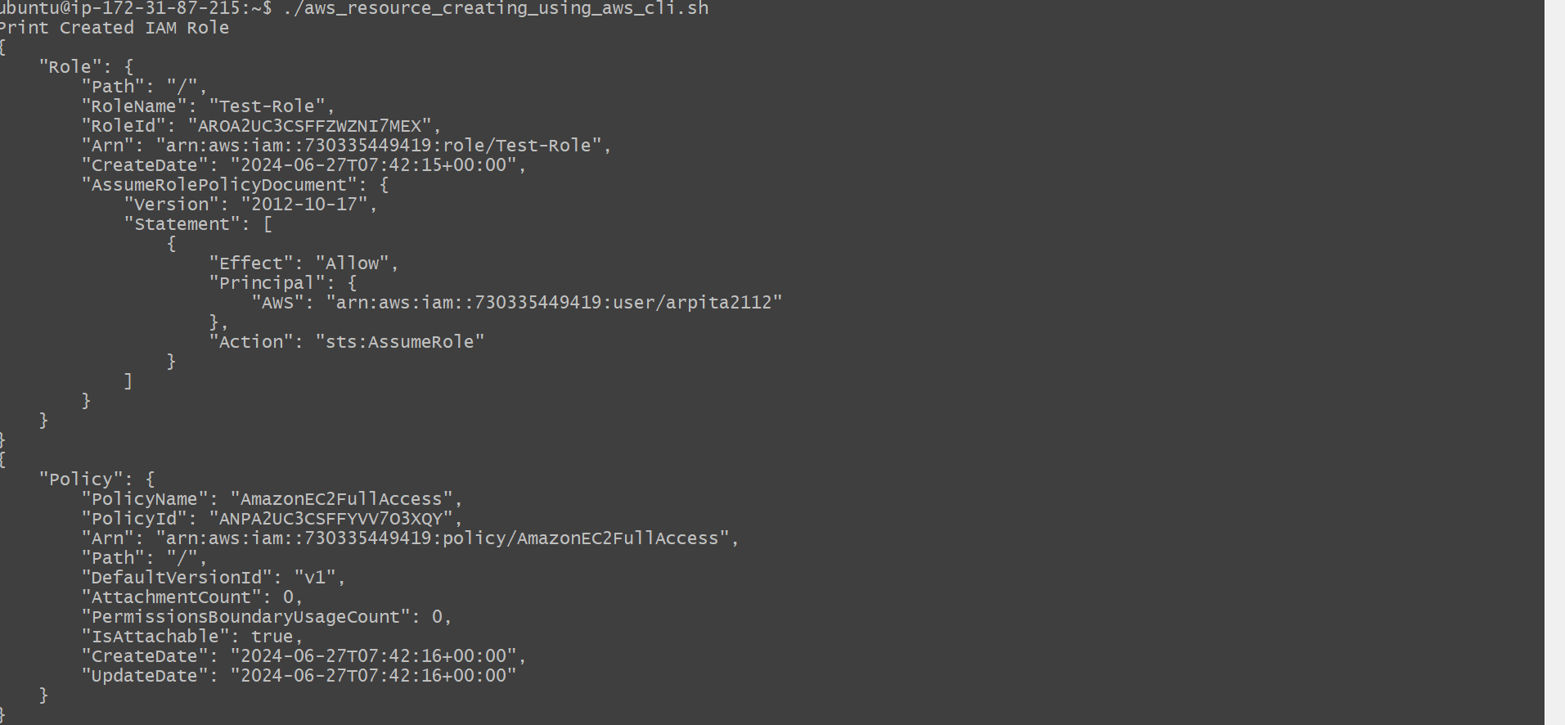

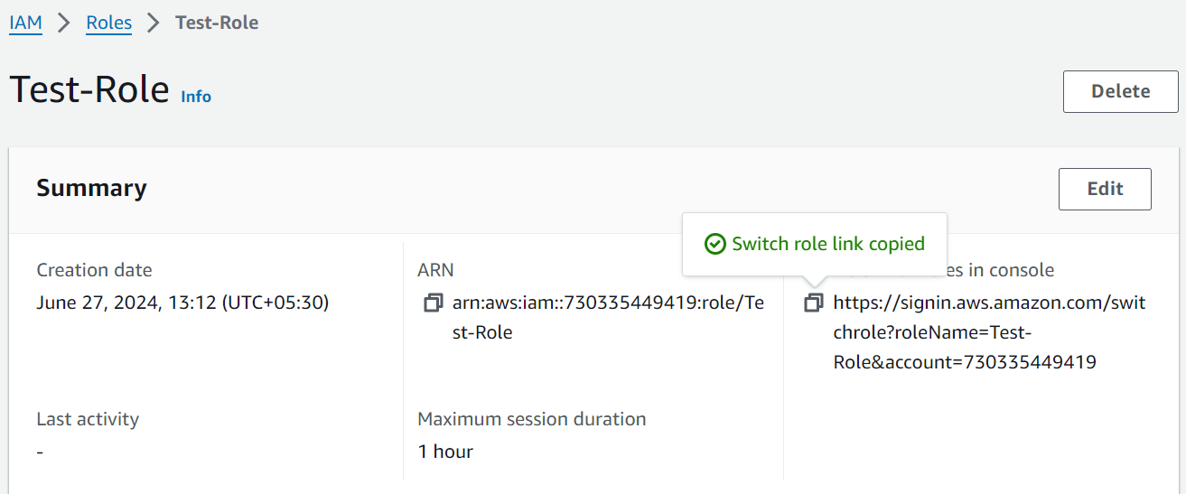

After pasting this link in browser I got my IAM role to perform action : -

